Arc-Buffalo-Effigy-Cherokee-Kentucky

|  |  |
| --- | --- |
| [BUFFALO EFFIGY](http://www.ebay.com/itm/301915303447) | [BUFFALO EFFIGY](http://www.ebay.com/itm/301915303447) |

tan hard stone effigy of a buffalo and it is a buffalo standing, so amazing was the artistic ability of ancient Native Americans, I found this in Rockcastle Co., Ky. in 2010, just a beautiful artifact and a treasure, this is of museum quality. the measurements are of: the buffalo ; 4" wide 2 1/8 tall by 1" thick. IT IS VERY RARE and guaranteed authentic for life, I found this while surface hunting on my own private property in South Eastern Kentucky., no caves, graves or any sacred sites disturbed. Free shipping.

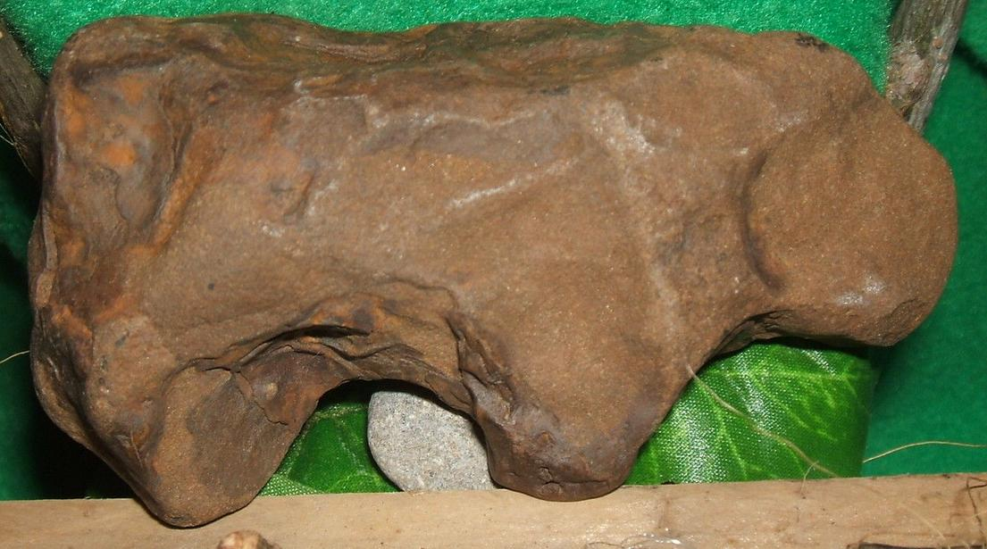

### buffalo standing, so amazing was the artistic ability of ancient Native Americans, I found this in Rockcastle Co., Ky. in 2010, just a beautiful artifact and a treasure, this is of museum quality. the measurements are of: the buffalo ; 4" wide 2 1/8 tall by 1" thick. IT IS VERY RARE and guaranteed authentic for life, I found this while surface hunting on my own private p

### roperty in South Eastern Kentucky., no caves, graves or any sacred sites disturbed. F Delivery package 1 of 1    FAST 'N FREE

Estimated delivery Saturday, Apr 9, 2016

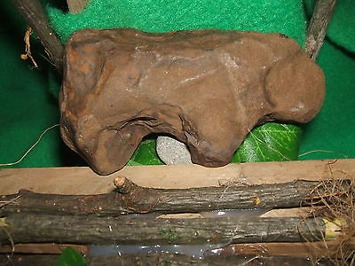

#### [,AUTHENTIC BUFFALO EFFIGY](http://www.ebay.com/itm/301915303447)

|  |  |
| --- | --- |
| Item price | $53.00 |
| Quantity | 1 |
| Item number | 301915303447 |
| Shipping service | USPS Priority Mail Medium Flat Rate Box |

## Shipping address

Ralph J Coffman Jr

149 Atlantic Ave

Swampscott MA 01907-2427

United States

## Order total

|  |  |
| --- | --- |
| Subtotal | $53.00 |
| Shipping | Free |

**Total**

$53.00

Order placed on

Sunday, Apr 3, 2016

Payment method

PayPal

Payment date

Sunday, Apr 3, 2016